  - The Yarra Riverkeeper Association: Yarra Atlas Seminar Report
Introduction of the Yarra Riverkeeper Association

The Yarra Riverkeeper Association speaks for the Yarra, Melbourne’s own beautiful, resilient, iconic River. The Association is the credible and authoritative voice for the River. It is an independent community of citizen-advocates that works solely in the interest of the river. The spokesperson of the Association is the Yarra Riverkeeper, and the Riverkeeper boat is permanently moored in the Yarra and patrols the River. As the population of Melbourne balloons and demands for open spaces grow, our River is coming under increasing pressure.

Introduction to Seminar Series

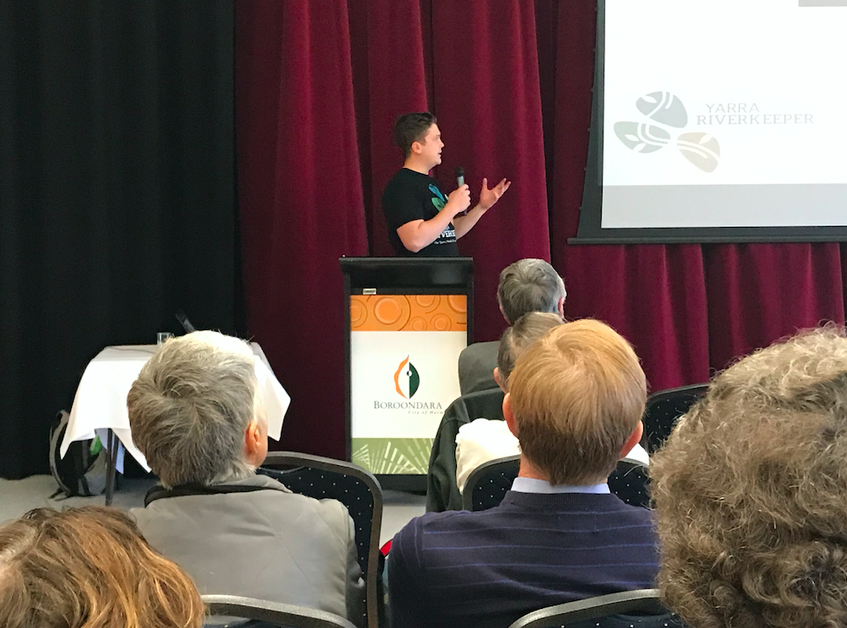
The Yarra Riverkeeper Association has developed a Seminar Series with the goal of sharing knowledge of tools and topics that help to care for the Yarra River. The seminar series invites expert speakers to talk to about their topic to create a conversation between industry experts and the community.

Introduction of Yarra Atlas Seminar

This instalment of the seminar series was the Yarra Atlas Seminar which had as an objective to give an overview of the Yarra Atlas. The purpose of the seminar was to give the community an update on how the development of the Atlas is going and what the next steps are for us and this project. This instalment of the Seminar Series took place at the Park View Room in the Boroondara City Council.

Sponsors

We would like to thank the City of Boroondara for their support throughout this seminar. As well, we would like to thank the Port Phillip Bay Fund for their support throughout the development of the Yarra Atlas.

Introduction to speakers

Andrew Kelly is the Riverkeeper and has extensive knowledge of the Yarra River. He has been acting as the Riverkeeper for 5 years and is responsible for being an essential part of legislations being passed and changes being made in regards to the health and future of the Yarra River.

Anton Tejeda is the Yarra Atlas Manager. Anton started at the Yarra Riverkeeper Association as a volunteer and eventually was appointed as the manager. He has a Bachelor of Environments and Society from RMIT.

Birgita Hansen is a research fellow in the Centre for eResearch and Digital Innovation at Federation University Australia. Birgita has a long-standing history of working with volunteers in shorebird conservation.

Report

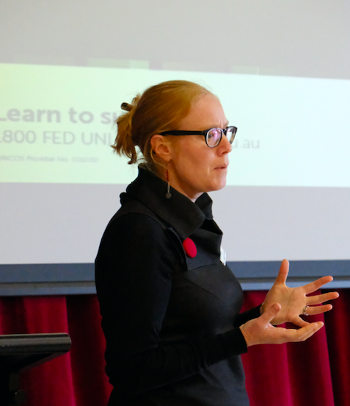
The purpose of the Yarra Atlas Seminar was to educate the community and fellow friends of groups about the Atlas and what it can do. The morning was started off by Anton Tejeda who gave a brief overview of the Yarra Atlas. During his presentation, Anton explained what the Atlas will house. Within its capabilities, that Atlas will have many layers which will house specific information about flora, fauna, water quality, biodiversity, sites of cultural significance and heritage, among others. These layers will be used to overlay against each other and generate reports which will make it simple for community to understand and digest the data that we have presented.

The second presenter, Birgita Hansen from CeRDI, presented the technological capabilities of the Atlas. Birgita mentioned that given that we have major players as our supporters, including the Atlas of Living Australia, we will have access to many data sources. One of these data sets is the Frog Census which has been fed into the ALA for over 10 years and has been put into the Atlas. Another data source that Birgita talked about was Melbourne Water’s data repository which includes data from many of Melbourne Water’s exercises to protect the waterways and to ensure their health through regular testing.

One of the challenges we have found in searching for the datasets is the ethics of the process. While some organisations have their data freely available on their website, the Yarra Riverkeeper Association contacts every data owner to get their permission to use their data before uploading the set to the Atlas.

The presentations were followed with a Q&A session which had as a purpose to create a discussion and open the floor to doubts and recommendations that the community might have.

One of the questions, which kept coming up and created a great deal of discussion was wether the data contributors would have direct access to the platform to update or change their data. Unfortunately, this will not be possible. This is due to the format in which data must be arranged to be recognised and presented correctly on the Atlas platform. This might cause time delays for contributors when uploading new data but it will guarantee that the data is presented, with its corresponding metadata, in the correct way. We will act as keepers of the new data until it can be sent to CeRDI for evaluation and upload.

However, contributors will still have some level of direct control. Within the Atlas, our tech developers have added a submissions page which allows anyone to send in their observations. Whether they might be of animals, flowers, waste, or a nice sight in the Yarra River, we will have them displayed in the submissions area. The approval process for these observations is less strict and quicker. This submissions area also opens up a component of citizen science which engages our community in a deeper way by having the community be the data creators. This capability has been successful with other, albeit different projects, and will be a test for the Atlas. This is in hopes of developing stewardship for Yarra River residents in their area of the river.

Acknowledgements

We would like to thank everyone who attended the seminar, it was an informative morning that made everyone in the room think outside the box. The Riverkeeper team got many questions, some of which we had not thought about and now we are planning for them.

We would like to again, thank our sponsors, Port Phillip Bay Fund and the City of Boroondara for their help, whether it was financial or otherwise.

These events are only possible because of the community, so the Yarra Riverkeeper Association thanks you for your support and encouragement.
